|  |
| --- |
| TECHNICAL REPORT |

|  |
| --- |
| Data Science (MSDS) |

|  |  |
| --- | --- |
| Fall 23 |  |



Contents

Project Name 2

Executive Summary 2

Technical Report 3

Highlights of Project 3

Submitted on: 3

Abstract 4

Methodology 5

Results Section 5

Discussion 6

Conclusion 6

Contributions/References 7

|  |
| --- |
| Analyzing Selling price of used cars |

|  |  |  |
| --- | --- | --- |
| Executive Summary The research on analyzing the selling price of used cars offers a thorough assessment of the numerous aspects impacting pre-owned vehicle pricing. Important factors influencing the resale value of automobiles have been found through thorough data gathering and analysis, providing important insights into the dynamic nature of this market.  For example, Mani is our friend, and he wants to dispose of his car. However, he is not aware of how much he should ask for his car. He wants to obtain the maximum profit, however, at the same time, he hopes that it will not be expensive for someone who may desire to have it. Therefore, in this case, we – a data scientist, can assist our friend Mani | | |
| The Fastest- and Slowest-Selling New and Used Cars in Today's Market -  iSeeCars.com | | |
| **Team Members:**  **1.Gannavarapu Lalitha Sravani**  **2.Daddanala Kaleswara Manikanta**  **3.Kaluva Kolanu Venkata Seshadri**  **4.Dhanala Rupesh Kumar** | **Questions?**  Contact : [lgann3@unh.newhaven.edu](mailto:lgann3@unh.newhaven.edu)  [kdadd3@unh.newhaven.edu](mailto:kdadd3@unh.newhaven.edu)  [vkalu3@unh.newhaven.edu](mailto:vkalu3@unh.newhaven.edu)  [rdhan4@unh.newhaven.edu](mailto:rdhan4@unh.newhaven.edu) |  |

|  |
| --- |
| Technical Report |

|  |  |
| --- | --- |
| **Title of Project:** **Analyzing selling price of used cars** | Used Vehicle Market Size In 2023 : Share, Trends, Opportunities Analysis  Forecast Report By 2030 |
| Highlights of ProjectThe study started with a thorough investigation of the factors affecting used automobile sales prices. Through the integration of large datasets and the application of sophisticated analytical methods, the research investigated the complex variables influencing the used car market's resale value.Submitted on:12/06/2023. |

## Abstract

The study's main objective is to conduct a comprehensive analysis of the factors affecting used automobile prices in the secondary auto market. utilizing large datasets that include factors like year, make, model, mileage, condition, and location.

Based on the variables observed, predictive models constructed using advanced machine learning algorithms demonstrated a high degree of accuracy in predicting the possible selling price of used cars. For those involved in the automotive business, these models are useful resources that support estimations of prices and decision-making procedures.

**Add your elevator pitch video link here ()**

**https://github.com/gannavarapu-lalitha-sravani/Analysing-selling-price-of-used-cars.git**

Introductory Section

Let’s think like data scientists and clearly define some of his problems: For instance, what about the prices of other cars and their specifications? What are the factors that determine the cost incurred on cars? Colour? Brand? What else affects the sale price or does horsepower influence it too?

Review of available research

A good follow-up to the introductory section is a review of available relevant research on the subject matter. The length of the literature review section depends upon how contested the subject matter is. In instances where the vast majority of researchers have concluded in one direction, the literature review could be brief with citations for only the most influential authors on the subject. On the other hand, if the arguments are more nuanced with caveats aplenty, then you must cite the relevant research to offer adequate context before you embark on your analysis. You might use the literature review to highlight gaps in the existing knowledge, which your analysis will try to fill. This is where you formally introduce your research questions and hypothesis.

## Methodology

The project's methodology for examining used car sales prices included a methodical approach to data collection, analysis, modeling, and insight extraction. The actions taken can be summed up as follows:

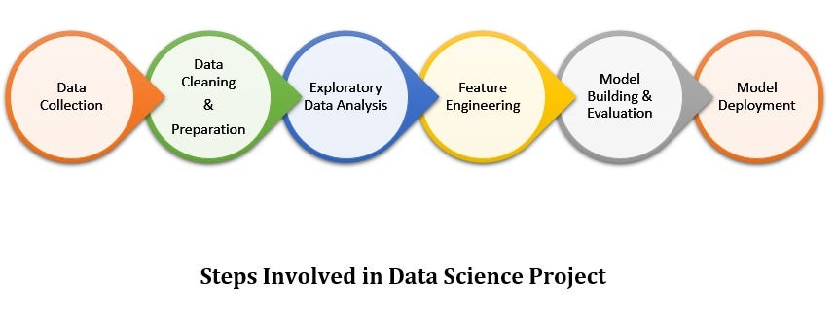

## Results Section

In conclusion, our data analysis journey aimed to empower individuals, such as our friend Mani, in making informed decisions when selling their used cars. By delving into a dataset rich with information about various car attributes, we extracted valuable insights that shed light on the nuanced dynamics influencing car prices.

Our analysis began with the exploration of factors contributing to the sale price of used cars. We scrutinized variables such as engine size, fuel type, brand, and body style, unveiling patterns that could significantly impact the perceived value of a vehicle. Through visualizations like box plots, scatter plots, and heatmaps, we brought these relationships to life, providing a visual narrative that aids in understanding the intricate interplay of different features.

The data cleaning and preprocessing steps were crucial in ensuring the reliability of our analysis. We addressed missing values, converted data types, and employed techniques such as one-hot encoding to transform categorical variables into a format conducive to statistical analysis.

Furthermore, our grouping and aggregation exercises allowed us to discern average prices based on key categories such as drive wheels and body style. These insights can prove instrumental in guiding pricing strategies, providing a nuanced understanding of how specific car features align with market expectations.

The application of ANOVA added a statistical layer to our analysis, enabling us to identify significant differences in prices among different car makes. This information is vital for individuals like Mani, allowing them to benchmark their car's value against comparable models in the market.

While our analysis provides valuable insights, it is essential to acknowledge its limitations. The dataset may not capture all relevant variables influencing car prices, and future research could explore additional data sources to refine our understanding further.

In essence, our data analysis journey equips individuals like Mani with a comprehensive toolkit for pricing their used cars strategically. By leveraging the power of data, we enable informed decision-making in a market where value perception is influenced by a myriad of factors. As we conclude this analysis, we affirm the transformative potential of data science in empowering individuals to navigate the complex landscape of used car transactions.

## 

## Discussion

Let’s think like data scientists and clearly define some of his problems: For instance, what about the prices of other cars and their specifications? What are the factors that determine the cost incurred on cars? Colour? Brand? What else affects the sale price or does horsepower influence it too?

These are some of the questions we as data analysts/data scientists can begin pondering upon. We’ll therefore require some data in order to answer these questions. However, this data is in its raw form. Therefore, we need to look at it first. We have it us in .csv/.data file format.

## Conclusion

In the "conclusion" The probable selling price of used cars was forecasted with noteworthy accuracy by predictive models constructed using advanced machine learning algorithms, taking into account the variables that were detected. For those involved in the automotive business, these models are useful resources that support estimations of prices and decision-making procedures.

## Contributions/References

https://archive.ics.uci.edu/ml/machine-learning-databases/autos/imports-85.data